Technical Report: Agentic Domain-Specific RAG System
1. Introduction
This project presents the design and implementation of a production-grade Agentic Retrieval-Augmented Generation (RAG) system for narrative, thematic, and character analysis of curated film documents. The system enhances traditional Large Language Models (LLMs) by integrating domain-specific retrieval, dynamic decision-making, external tool usage, conversational memory, and MLflow-based observability.
Unlike standard LLM systems that rely solely on pre-trained knowledge, this architecture ensures that responses are grounded in curated data, dynamically enriched using external sources, and continuously tracked for performance and transparency.
2. System Architecture Overview
The system follows a modular, multi-stage pipeline implemented in Databricks:
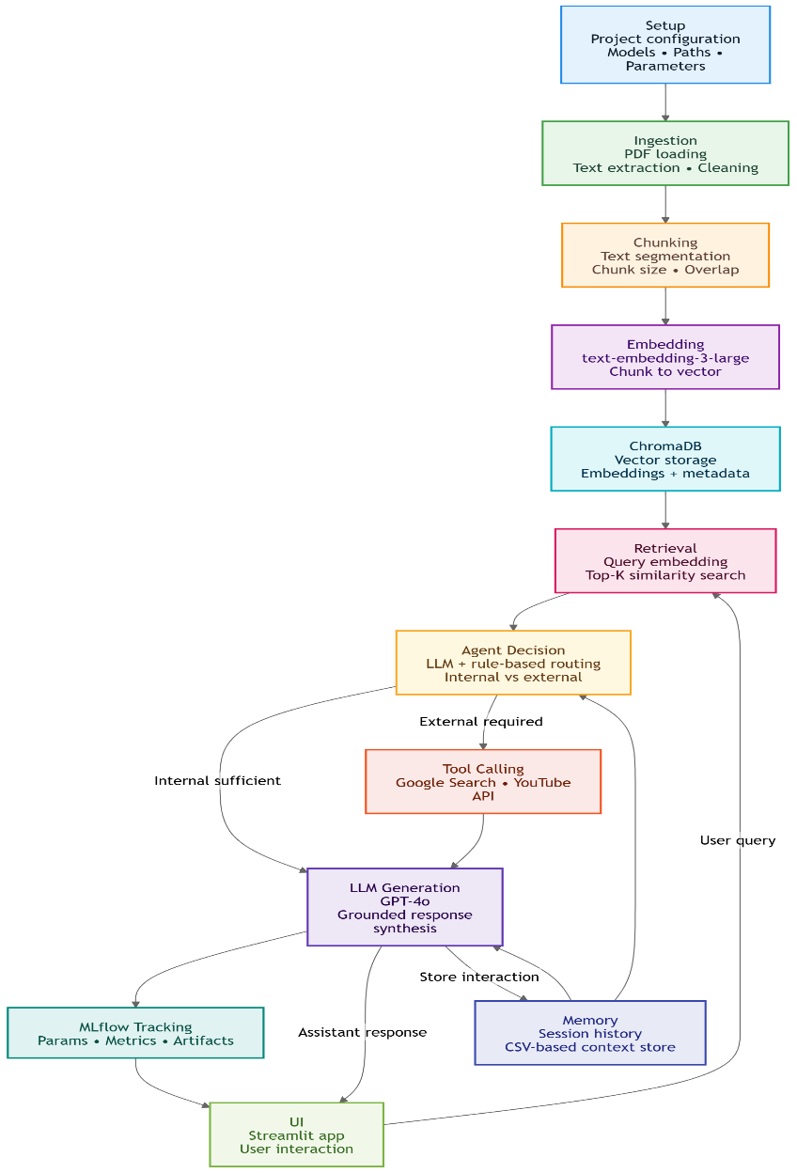
Each stage is designed to perform a specific transformation, ensuring scalability, maintainability, and clarity in execution.
3. Project Setup & Configuration
The system is initialized with a centralized configuration that defines:
- Embedding Model: text-embedding-3-large
- LLM Model: GPT-4o
- Chunk Size: 1200
- Chunk Overlap: 200
- Top-K Retrieval: 5
- Temperature: 0
A structured directory system is created to manage:
- Raw documents
- Processed metadata
- Vector database
- Logs and reports
4. Document Ingestion
Raw PDF documents are ingested and processed using PyMuPDF for text extraction. Each document undergoes:
- Page-level text extraction
- Text cleaning and normalization
- Aggregation into full document text
A structured dataset is generated and stored as:
documents_metadata.csv
Each record contains:
- doc_id
- file_name
- source_path
- raw_text
- character count
- ingestion timestamp
This stage transforms unstructured PDFs into machine-readable structured data, forming the foundation for downstream processing.
5. Chunking & Metadata Generation
To optimize retrieval, documents are split into smaller semantic units using a fixed-size overlapping chunking strategy:
- Chunk Size: 1200 characters
- Overlap: 200 characters
This ensures:
- Context preservation across chunk boundaries
- Improved retrieval granularity
Each chunk is stored with metadata:
- chunk_id
- doc_id
- chunk_index
- chunk_text
- chunk size and overlap
- timestamp
Output is stored as:
chunks_metadata.csv
These chunks act as the atomic units of retrieval in the RAG pipeline.
6. Embedding & Vector Database (ChromaDB)
Each chunk is converted into a vector embedding using the text-embedding-3-large model.
These embeddings are stored in ChromaDB, a persistent vector database that supports:
- Efficient similarity search
- Metadata storage alongside embeddings
ChromaDB enables the system to perform semantic retrieval by comparing query embeddings with stored vectors.
7. Retrieval Mechanism
When a user query is received:
- The query is converted into an embedding vector
- ChromaDB performs similarity search
- The Top-K (5) most relevant chunks are retrieved
These chunks are used to construct the context for response generation, ensuring that the LLM operates on relevant domain-specific information.
8. Agentic Decision Layer
A key innovation in this system is the Agentic Decision Layer, implemented using an LLM.
The system evaluates:
- User query intent
- Sufficiency of retrieved internal context
The agent selects one of the following actions:
- INTERNAL_ONLY
- GOOGLE_SEARCH
- YOUTUBE_SEARCH
- GOOGLE_AND_YOUTUBE
This decision is made using:
- LLM-based reasoning (structured output)
- Rule-based overrides for explicit intents
This hybrid approach ensures both precision and flexibility.
9. Tool Integration
When required, the system dynamically calls external tools:
- Google Search (via SerpAPI)
- YouTube Search (via YouTube API)
Results are formatted and injected into the prompt as additional context.
This enables the system to:
- Handle real-time queries
- Provide links, videos, and external references
- Overcome limitations of static document knowledge
10. LLM-Based Response Generation
Final responses are generated using GPT-4o, with inputs including:
- User query
- Retrieved document context
- External tool results (if any)
- Conversation history
Prompt design enforces:
- Grounded responses
- Use of evidence
- Reduced hallucination
The result is a context-aware, domain-specific, and reliable answer.

11. Conversational Memory
The system implements session-based memory using a CSV-based storage:
session_logs.csv
Each interaction stores:
- session_id
- user question
- model response
- decision action
- timestamps
For each new query:
- Last N interactions (lookback = 5) are retrieved
- Injected into the prompt
This enables:
- Multi-turn conversations
- Context continuity
- Improved follow-up handling

12. MLflow Tracking & Observability
The system integrates MLflow (Databricks) to track each query as a run.
Tracked components include:
- Parameters: question, session_id, decision action
- Metrics: latency, number of sources retrieved
- Artifacts: full response JSON
This provides:
- Debugging capability
- Performance analysis
- Experiment reproducibility
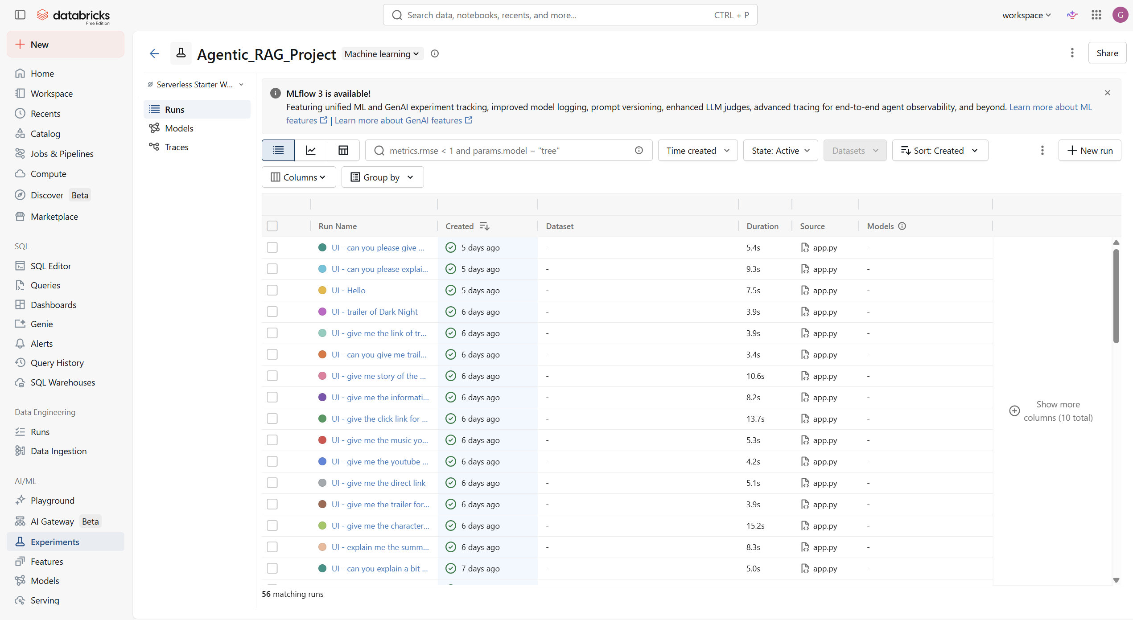
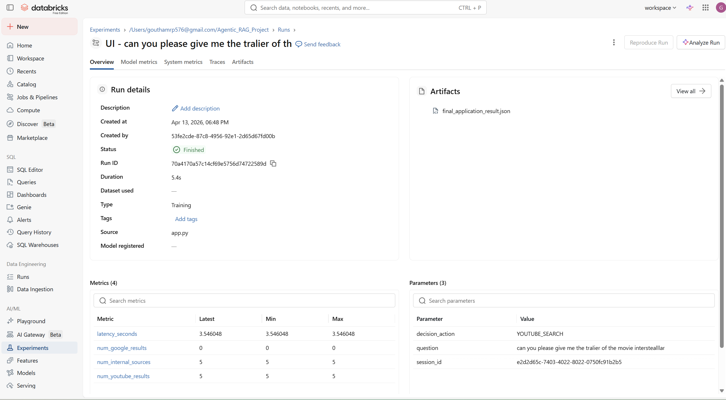

13. Final Application (Deployment)
The complete system is deployed as a Streamlit application on Databricks.
Frontend features:
- Chat-based interface
- Session management
- Display of sources and metadata
Backend integration:
- Retrieval pipeline
- Agentic decision logic
- Tool calling
- Memory system
- MLflow tracking
This results in a fully functional, production-grade AI application.

Stream lit UI
